Vertofi WhatsApp-Based Micro Accounting System

The world’s simplest accounting system for MSMEs who hate software

✅ 1. What This System Is
A complete accounting workflow powered entirely through WhatsApp — no apps, no logins, no learning curve.
Your clients do only one thing:
➡️ Send bills, expenses, bank screenshots, or voice notes on WhatsApp.
Vertofi’s backend does EVERYTHING automatically:
✔ Extract data
✔ Categorize transactions
✔ File GST-ready entries
✔ Update ledgers
✔ Generate reports
✔ Send reminders
✔ Alert for mismatches
✔ Save documents in cloud
✔ Map to bank statements
This is a blue-ocean feature — hardly any accounting firm has implemented a reliable WhatsApp-first accounting system.

✅ 2. Why MSMEs Love This
Most small business owners:
❌ Don’t like complex accounting software
❌ Don’t update books regularly
❌ Don’t organize documents properly
❌ Don’t remember expenses
❌ Drop accounting work due to workload
But they ALL know how to use WhatsApp.
So you shift accounting from
Data Entry → Data Collection → AI Automation

✅ 3. How Vertofi Micro Accounting Works (Step-by-Step)

STEP 1 — Client sends anything on WhatsApp
Supported inputs:
📸 Photos
• Supplier bills
• Fuel receipts
• Delivery challans
• Purchase invoices
• Bank deposit slips
🎙 Voice Notes
• “Paid ₹4,000 for diesel today.”
• “Received payment from client.”
• “Cash withdrawal ₹10,000.”
💬 Text Messages
• “Salary paid ₹1,20,000.”
• “Bought materials ₹8,500.”
• “Client paid 50% advance.”
📁 Documents
• PDF invoices
• Tally exports
• Excel bank statements

STEP 2 — Vertofi AI Bot Processes Data Automatically
AI tasks performed:
- OCR Scanning
Reads the bill → extracts details:
- Vendor name
- Amount
- GST breakdown
- Category
- Date
- Payment mode
- Natural Language Interpretation
Voice message → converted to text → mapped to accounting entry.
- Duplicate Detection
AI checks if the same bill was sent earlier.
- Category Prediction
Automatically tags categories like:
- Fuel
- Materials
- Repairs
- Travel
- Office expenses
- GST Matching
Links supplier invoices with GST portal to confirm:
✔ Invoice uploaded
✔ ITC available
- Bank Sync Matching
Entries are matched with bank statements to prevent mismatches.

STEP 3 — Ledger Automatically Updates
The AI creates entries in:
✔ Purchase ledger
✔ Sales ledger
✔ Expense ledger
✔ Cash book
✔ Bank book
✔ GST Input Credit
✔ GST Output
✔ Petty cash
✔ Staff payments
Everything is synced to the accounting software you use:
Tally / Zoho Books / QuickBooks / BUSY / MyBillBook / Odoo.

STEP 4 — Client Gets Instant Confirmation
Within seconds the client receives:
“Entry posted successfully:
Fuel Expense – ₹4,000 – Dated 17 Nov – Paid by Cash.”
OR
“GST ITC not available for this bill — vendor has not filed GSTR-1.”
OR
“Possible duplicate bill detected.”

✅ 4. Additional Genius Features

1. Auto-Reminder System
If client forgets a task:
🔔 “Please send petrol bill for the week.”
🔔 “Send salary details for November.”
🔔 “Send sales invoices for GST filing.”

2. WhatsApp-Based Monthly Reports
Every month Vertofi sends:
📊 Profit & Loss
📊 Cashflow
📊 Expense breakdown
📊 GST summary
📊 Pending invoices
📊 ITC claim report
Reports are sent as:
• Image infographic
• PDF
• WhatsApp message summary

3. WhatsApp Approval Workflow
Example:
You: “Shall I file GST return at ₹32,400 payable?”
Client just taps Approve or Reject.

4. WhatsApp Document Vault
Every bill sent by client → automatically stored in cloud.
Client can request:
“Send all petrol bills for July.”
“Send invoice #322.”
“Send purchase invoices for Audit.”
AI retrieves instantly.

5. Fraud Prevention Alerts
If suspicious activity found:
⚠️ Duplicate cash withdrawals
⚠️ Unusual vendor pattern
⚠️ Large unexplained payments
⚠️ Pending bill mismatch
Client alerted immediately.

✅ 5. Business Benefits for Vertofi

1. Zero Effort Data Collection
No chasing clients for documents.

2. 80% Reduction in Data Entry Work
AI handles processing → your team finalizes only.

3. Scalable Model
Handle 300+ MSME clients with same staff.

4. Each Client Becomes a Daily User
Increases retention + more service upsells.

5. Big Competitive Advantage
No accounting firm provides a WhatsApp-only accounting system.

✅ 6. What You Can Brand It As
Here are name ideas:
⭐ Vertofi WhatsApp Accounting Engine
⭐ Vertofi Micro Accounting Hub
⭐ Vertofi ChatLedger™
⭐ Vertofi WhatsApp CFO
⭐ Vertofi One-Tap Accounting

✅ 7. How You Can Sell It to MSMEs

Simple pitch:
“Just send your bills on WhatsApp. We do all your accounting.”

Target audience:
- Retail shops
- Restaurants
- Traders
- Freelancers
- Small manufacturers
- Transporters
- Home businesses
- Agencies
Vertofi’s WhatsApp-Based Micro Accounting system DOES create and send bills automatically, including Sales Invoices, Purchase Entries, Credit Notes, and Debit Notes — all without the client opening any software.
Below is the clear, operational explanation 👇

✅ What Documents Vertofi Can CREATE Automatically

(Using only WhatsApp inputs)

🧾 Sales Invoice

🧾 Purchase Entry

🧾 Credit Note

🧾 Debit Note

🧾 Proforma Invoice

🧾 Receipt / Payment Voucher
🔹 1. Sales Invoice Creation (WhatsApp → Customer)
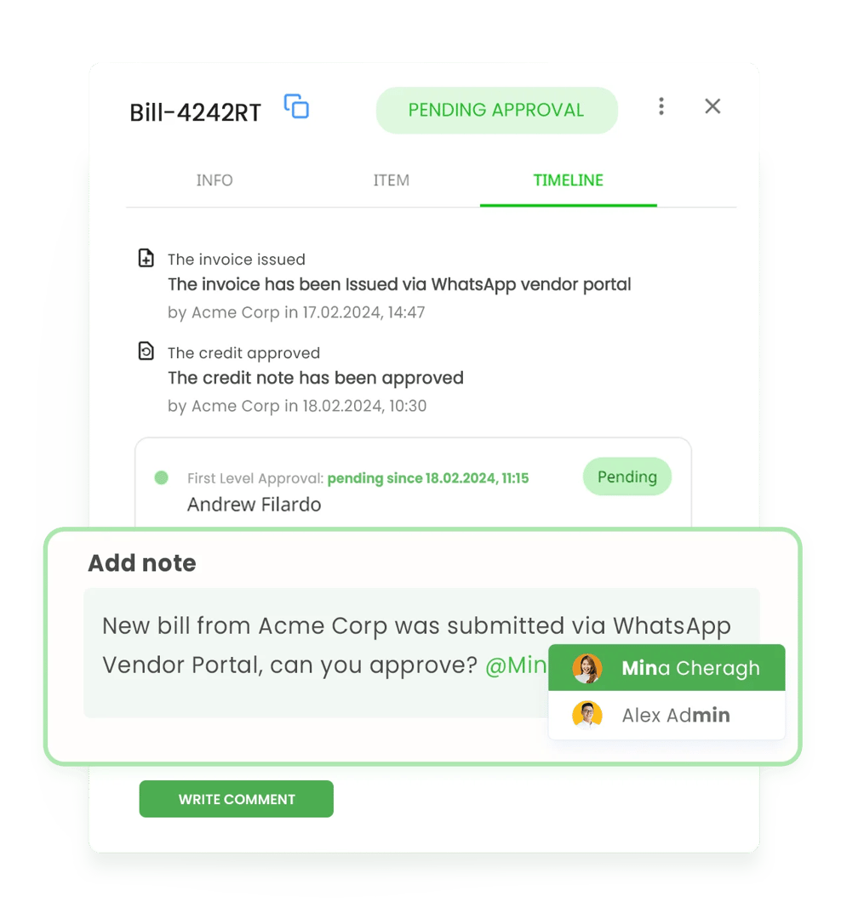
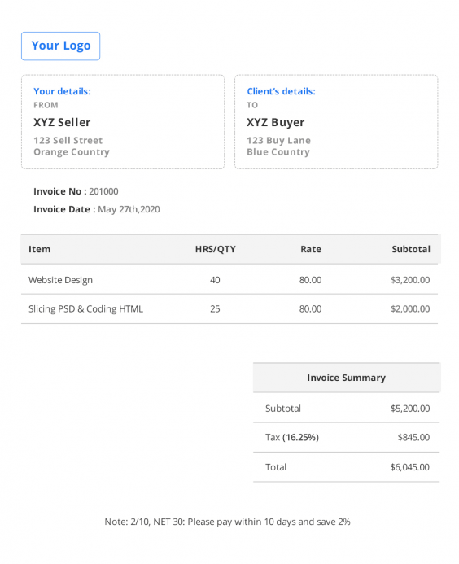
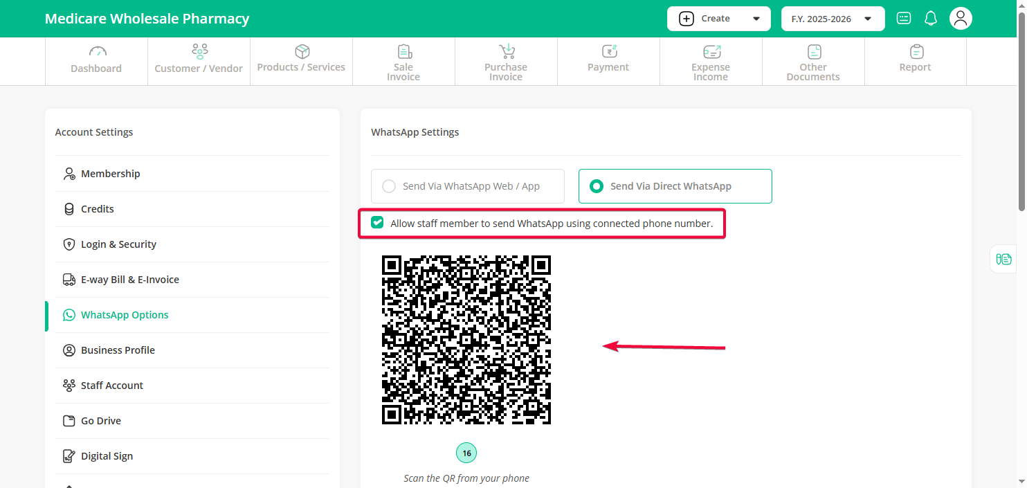

How it works
Client sends a message like:
“Create invoice for Ramesh Traders – ₹25,000 + GST – LED bulbs”
OR sends:
📸 Product photo
🎙 Voice note
📄 Rate list / previous invoice

Vertofi AI does
- Identifies customer
- Picks product/service
- Applies GST slab
- Calculates tax
- Assigns invoice number
- Applies company logo, GSTIN, bank details

Invoice output
- PDF GST invoice
- UPI QR + bank details
- Due date
- Terms & conditions

Delivery
✔ Sent to customer WhatsApp
✔ Sent to email (optional)
✔ Saved in sales ledger + GST return

🔹 2. Purchase Recording (Vendor Bills)
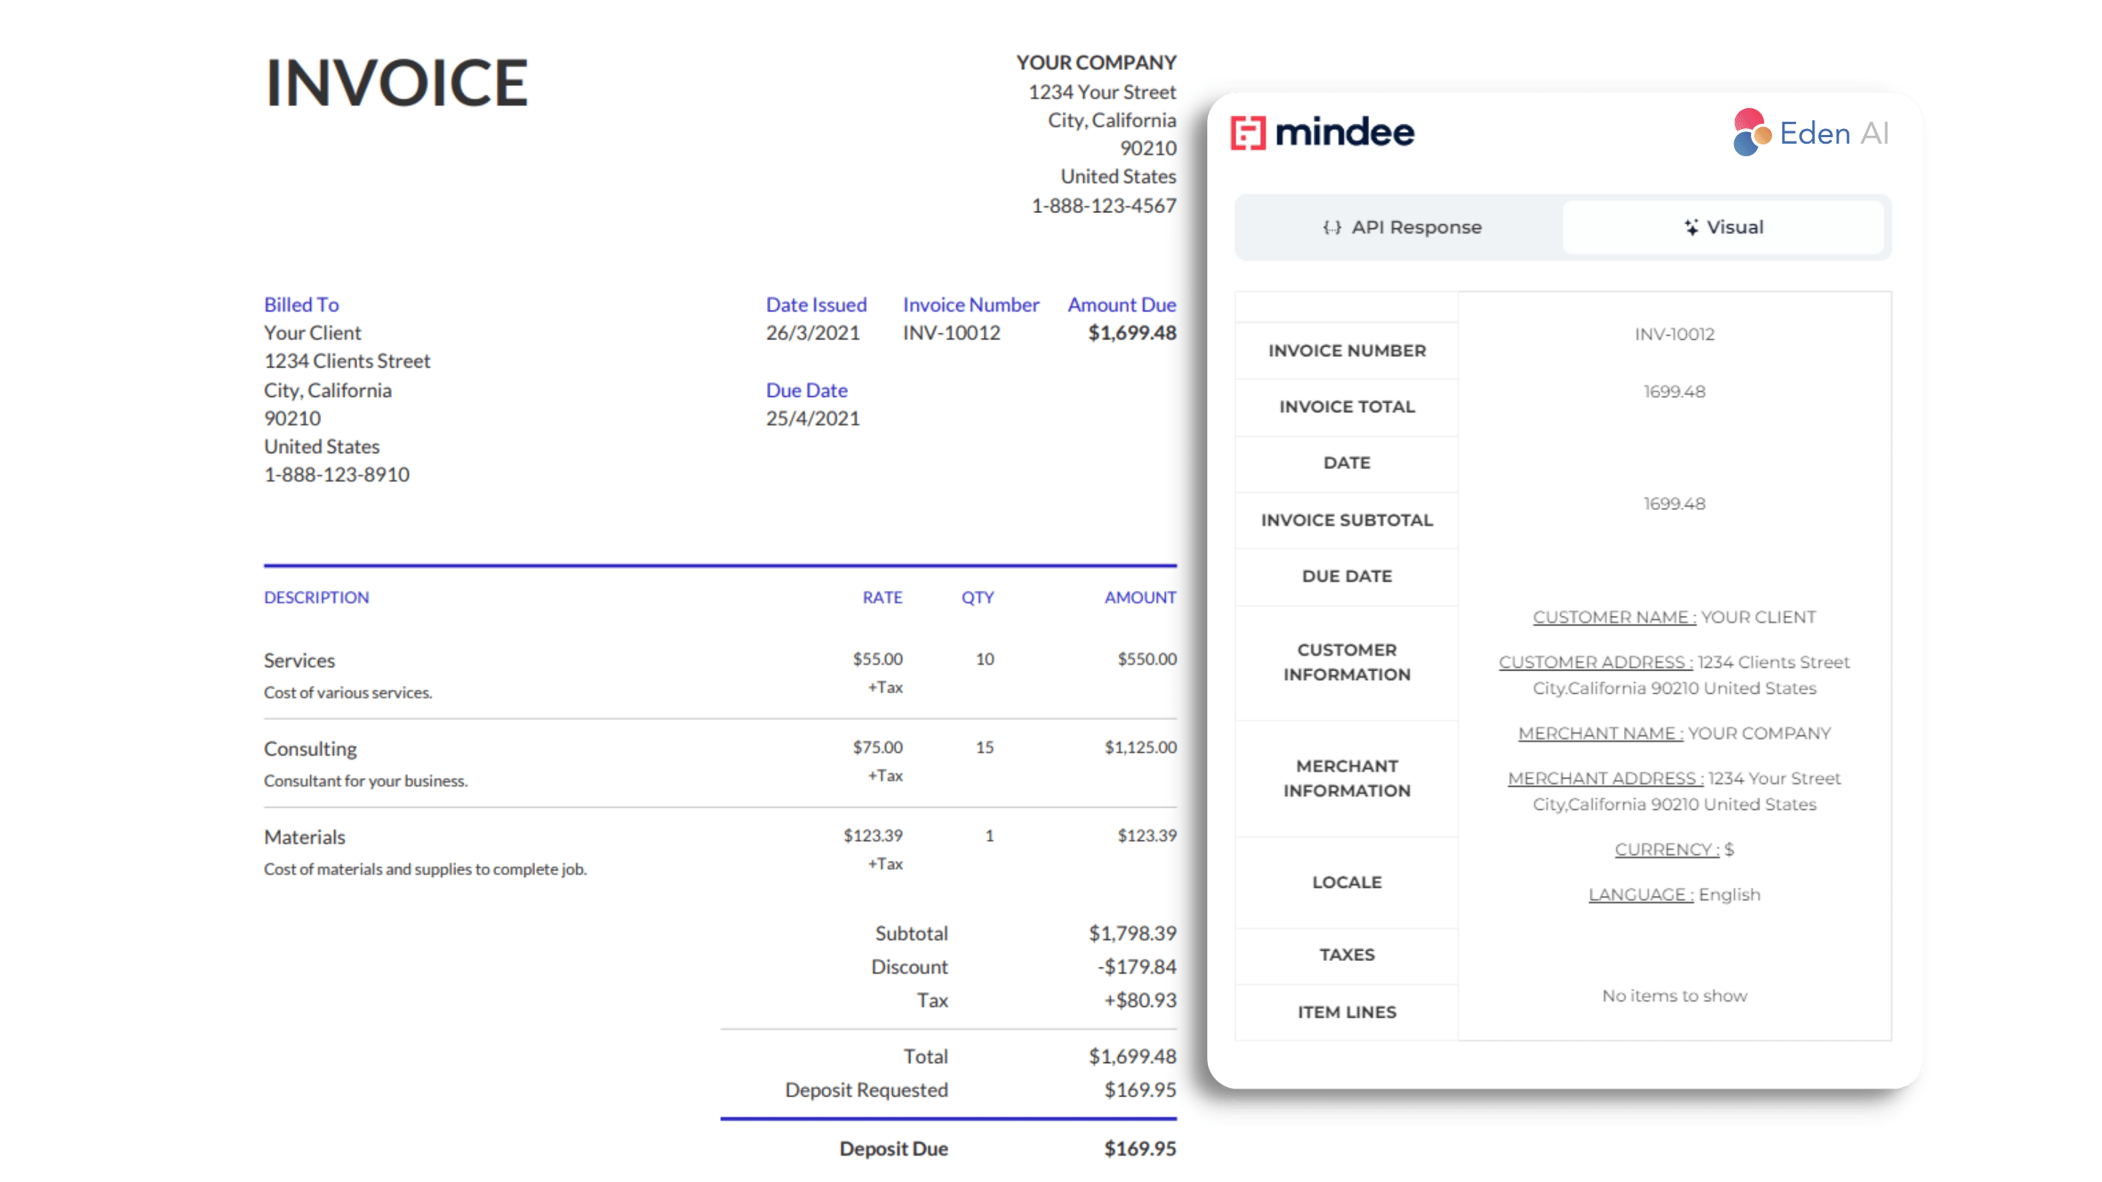
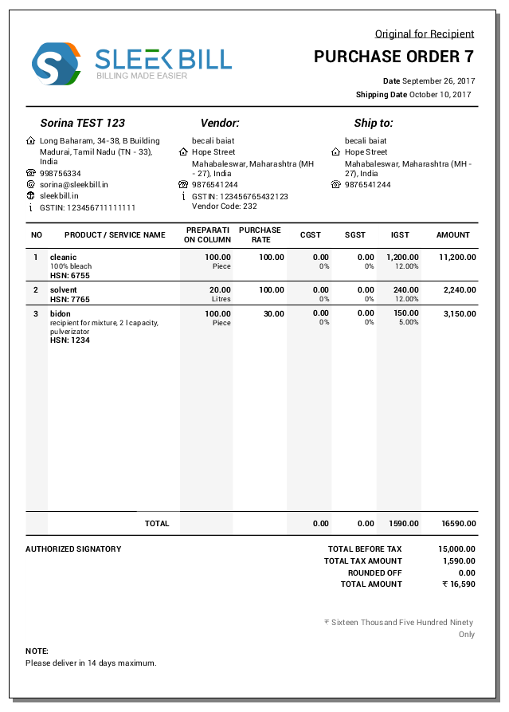
Client sends:
📸 Vendor bill photo / PDF
Vertofi:
- Extracts invoice details
- Matches with GSTR-2B
- Records purchase
- Claims ITC
- Updates payables
⚠️ If vendor hasn’t filed GST → warning sent
🔹 3. Credit Note Creation (Returns / Discounts)
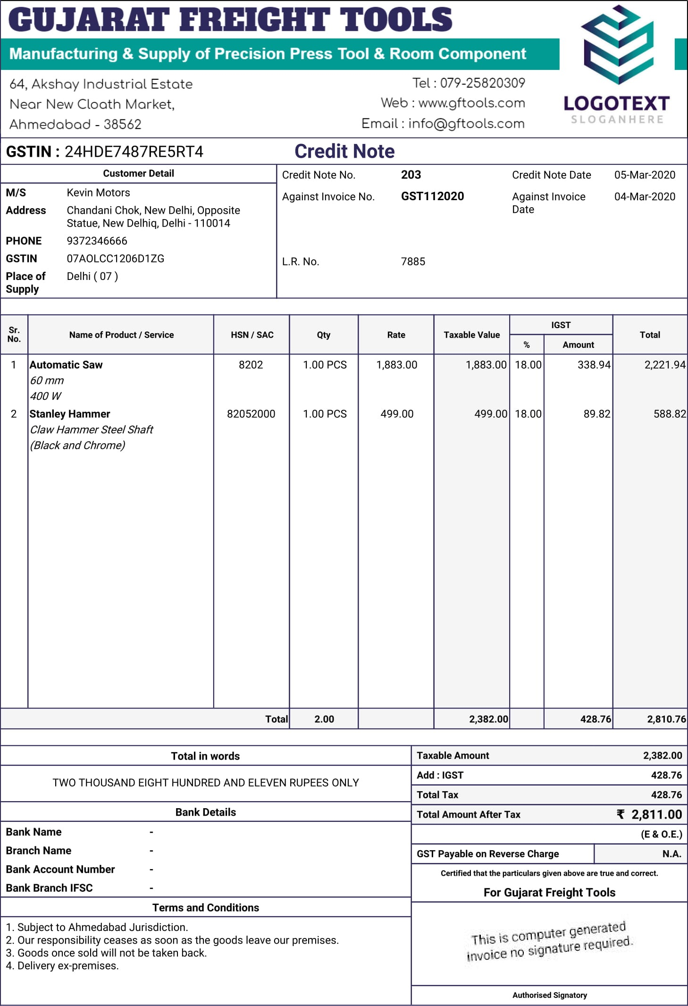

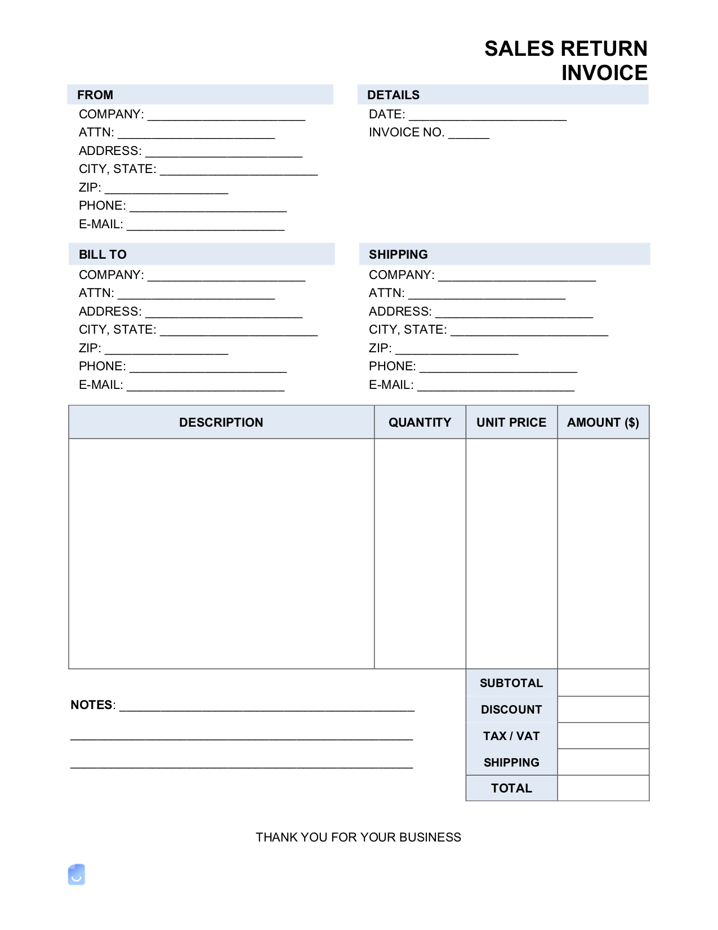
Client sends:
“Return invoice #VTF-021 – ₹3,000 damaged goods”
Vertofi:
- Generates GST-compliant credit note
- Adjusts GST liability
- Sends credit note to customer
- Updates returns + ledgers

🔹 4. Debit Note Creation (Extra Charges / Corrections)
Client sends:
“Add transport charge ₹1,200 to invoice VTF-021”
Vertofi:
- Generates debit note
- Adjusts receivables
- Sends to customer/vendor
- Syncs with GST

🔹 5. Auto-Trigger Scenarios (No Manual Request Needed)
Scenario | Vertofi Action
Sales return detected | Credit note created
Price mismatch | Debit note suggested
Advance received | Receipt voucher
Partial payment | Balance reminder
Overpayment | Credit note
Discount approved | Credit note

🔹 6. Approval & Control (Zero Risk)
Before sending anything externally:
✔ Owner approval via WhatsApp
✔ “Approve / Reject” buttons
✔ Editable preview
Nothing goes out without consent.

🔹 7. Compliance & Safety
- GST-compliant invoice format
- Auto numbering
- Audit trail
- Change history
- Document storage
- ISO-grade access control

🔹 8. Simple MSME Explanation (Your Sales Line)
“Just WhatsApp us.
We create invoices, send them to your customers, record purchases, manage returns, and handle GST — automatically.”

🔹 9. Why This Is Powerful
- No software learning
- Faster billing
- Fewer GST errors
- Better cashflow
- Higher client retention
- Perfect for MSMEs & traders

📲 Vertofi WhatsApp Command Formats

(Simple • Natural • Mistake-tolerant)

🧾 1. Sales Invoice Commands

✅ Create Sales Invoice
Format (Natural):
Invoice
Customer: Ramesh Traders
Item: LED Bulbs
Qty: 100
Rate: 250
GST: 18%
Ultra-Simple Format:
Invoice Ramesh Traders 100 LED Bulbs @250 +18%
Voice Note Allowed:
🎙 “Create invoice for Ramesh Traders for 100 LED bulbs at 250 plus GST.”

📤 Send Invoice
Send invoice VTF-021 to customer

📝 Edit Invoice
Edit invoice VTF-021
Change qty to 120

🛒 2. Purchase Entry Commands

✅ Record Purchase
Purchase
Vendor: Sri Ganesh Suppliers
Amount: 18,500
GST: Yes
Paid by: Bank
Or just send bill photo 📸

❌ Cancel Purchase
Cancel purchase invoice SG-445

🔁 3. Credit Note Commands (Returns / Discounts)

✅ Create Credit Note
Credit note
Invoice: VTF-021
Amount: 3,000
Reason: Goods returned
Simple:
Return 3000 from invoice VTF-021

📤 Send Credit Note
Send credit note CN-005

➕ 4. Debit Note Commands (Extra Charges)

✅ Create Debit Note
Debit note
Invoice: VTF-021
Charge: Transport
Amount: 1,200
Simple:
Add transport charge 1200 to invoice VTF-021

💰 5. Payment & Receipt Commands

✅ Record Payment Received
Received
From: Ramesh Traders
Amount: 15,000
Mode: UPI
Simple:
Ramesh paid 15000 by UPI

✅ Record Payment Made
Paid
To: Ganesh Suppliers
Amount: 9,000
Mode: Cash

📊 6. Reports & Summaries

📄 Monthly Report
Send March report

📊 GST Summary
GST summary for April

📈 Profit & Loss
P&L for FY 2024-25

⏰ 7. Reminders & Follow-ups

🔔 Set Reminder
Remind me to collect payment from Ramesh on 20th

📢 Send Payment Reminder to Customer
Send reminder to Ramesh for invoice VTF-021

📁 8. Document Retrieval Commands

📂 Get Old Bills
Send petrol bills for March
Send purchase invoices from Ganesh Suppliers

⚠️ 9. Corrections & Mistakes (Human-Friendly)
That amount is wrong
Duplicate bill
Cancel last entry
Vertofi responds with preview + fix options.

🔐 10. Approval Commands (Owner Control)
Approve invoice VTF-021
Reject credit note CN-005

🤖 11. Smart Auto-Commands (No Typing Needed)
Action | Trigger
Bill photo sent | Purchase auto-created
Voice note | Expense auto-logged
Bank SMS | Receipt auto-matched
Sales created | GST + ledger auto-updated
Due date crossed | Reminder auto-sent

🧠 12. Key Design Rules (Why This Works)
✔ No fixed syntax needed
✔ Supports spelling mistakes
✔ Supports Hindi / Telugu / English
✔ Voice → text supported
✔ Context-aware follow-ups
✔ Confirmation before posting

🏆 Your One-Line Sales Hook
“Type like WhatsApp. Accounting happens automatically.”

